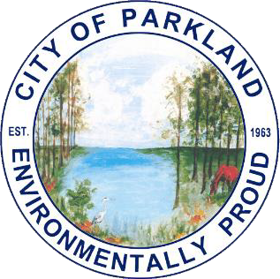

Dear Applicant:

City of Parkland Scholarship Application – 2025-2026
An annual scholarship for post-secondary City of Parkland students made possible through the City of Parkland, Silver Miller Law, Kennedy Legal Team, Mesa-Taylor Family, Eaton Family, Steinberg Family, The Bin Doctor and the Parkland Chamber of Commerce

Congratulations on your choice to continue your education beyond high school. We applaud your decision. The City of Parkland believes it is important for all students and citizens to be active in their community. Therefore, we have established scholarships in recognition of outstanding community or civic service to be used for post-secondary school related expenses. To be eligible for the scholarship opportunity, a completed application and all supporting materials must be received by 4:00 PM on Thursday, March 5, 2026. Six scholarships will be awarded $2500 each and are being funded by the City of Parkland, Silver Miller Law, Kennedy Legal Team, Mesa-Taylor Family, Eaton Family, Steinberg Family, and The Bin Doctor. One scholarship will be awarded $1000 and is being funded by the Parkland Chamber of Commerce.

To apply, you must be a Parkland resident eligible for high school graduation in the current year with a cumulative GPA of 2.5 or higher. This scholarship seeks to recognize students who demonstrate leadership, innovation, and collaboration or launched a community service initiative, and have performed civic service of a minimum of 50 service hours. After the initial application is reviewed, an interview will be requested for all finalists by the Parkland Community Advisory Board.

To be considered for the scholarship, you must provide the following documentation:
- Completed and signed scholarship application
- High school transcript (in sealed envelope from the school)
- Two (2) letters of recommendation -
  - One from your guidance counselor or a teacher
  - One from an individual who has worked with you on a community project
- ESSAY OF 250 WORDS OR LESS – Please attach a brief description of your community involvement with details of your community service project(s). Include a description of the impact your service has had on you.

* Please note that if you have already received a scholarship from the City of Parkland at any time, you are not eligible for additional scholarships.

All of the above items must be submitted by Thursday, March 5, 2026, 4:00 PM to:
City of Parkland
Attn: Scholarship Application
6600 University Drive
Parkland, FL 33067

Applications will not be accepted after the deadline. The scholarship winner will be announced in early summer.

On behalf of the City of Parkland, we wish you success in your future educational endeavors.

CITY OF PARKLAND
Scholarship Application

APPLICANT INFORMATION
Last Name: |  | First: |  | M.I.: | Date:
Street Address: |  |  |  | Apartment/Unit #:
City: | Parkland | State: | Florida | ZIP:
Phone: |  | E-mail Address:
High School attending:
How long have you lived in Parkland?:
List all High School and Community Service Related Activities
High School Extra-Curricular and Community Service Activities
Activity | Organization | # of Hours  per Month (Avg.)

POST-SECONDARY SCHOOL DATA
Please list the top three schools to which you applied for admission
School Name; | City/State:
Accepted?:
School Name: | City/State:
Accepted?:
School Name: | City/State:
Accepted?:
Anticipated Major:

EDUCATIONAL PLANS AND CAREER GOALS:
Please write a brief description explaining your future educational and career goals:

DISCLAIMER AND SIGNATURE
I certify that my answers are true and complete to the best of my knowledge.

Signature: Date:

Print Name:

